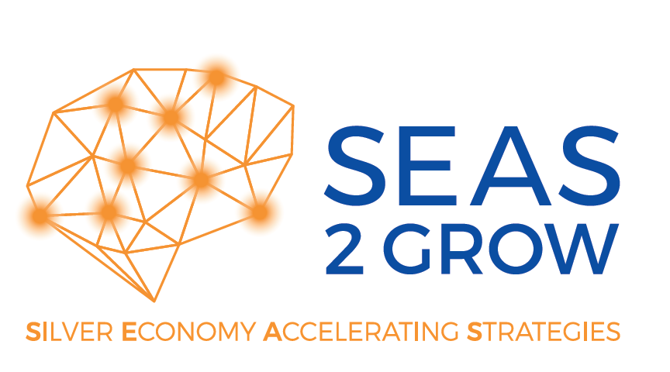
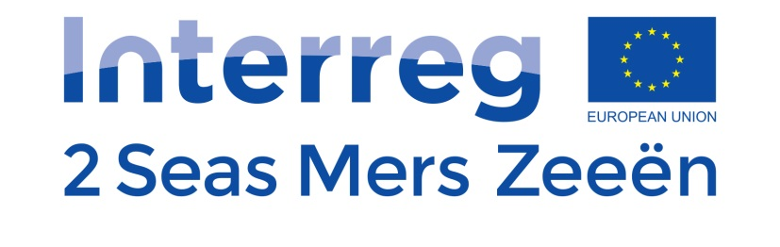
Registration form
Wave 3

Silver Economy Accelerator SEAS 2 Grow
Please send your registration form to:
contact@seas2grow.com

Deadline: 20 April 2018

www.seas2grow.com

A project supported by

Please fill in this form to register your innovation @Seas2Grow
(Part 1: max. 5 A4, front Arial 10)
Part 1 : Registration Innovation Seas2Grow
Date of registration
Title | Give your project a recognizable and clear name.
Contact person & contact data | Name, e-mail, phone number, address.
Organization | Name and short description of your organization / company. List up your VAT-number.  Describe briefly the background of the team (members) that work for this innovation in your organization and particularly the dedicated team that will be involved in piloting the innovation in the Silver Economy accelerator.
Challenge/opportunity | Description of the context of your innovation. What issues, problems or wishes have led to this innovation? Please include the necessary background, along with decisions already taken, if any.
Description and goal of your innovation | Describe briefly what your innovation is and what you want to achieve with your innovation. What are the final results of this project? Who is your target group? Do you already have a proof of concept? Which (R & D) developments do you still need to achieve your idea / product / service: briefly mention appropriate activities. Also specify if this innovation is new to your organization and / or new to the target market.  If some of the development/marketing activities are planned in parallel with the pilot project in Seas2Grow, you can also mention these activities here and indicate how you finance them.  Please mention if your product/service is CE-certified or not. Is a CE-certification in progress or not relevant?  You can add a link to your website or a youtube-video that explains your innovation.
Technology Readiness Level | Please indicate the correct Technology Readiness Level which stands for the maturity level of your technology/concept.  1: Basic principles observed and reported  2: Technology, concept or application formulated  3: Analytical and experimental functions or characteristics checked;  Proof of concept ready  4: Component(s) validated in laboratory environment  5: Component(s) validated in relevant environment  6: System prototype demonstrated in relevant environment  7: System prototype demonstrated in operational environment  8: Actual system completed and qualified through test and demonstration  9: Actual system proven through successful operations
Commercialization | What business model do you have in mind? Which buying customers do you have in mind? (B2B and / or B2C). What would be the pricing of your product/service? How do you reach these customers? Do you already have a market share in one of the participating regions? What is the biggest challenge for innovation for the (other) markets offered here? How can the project help you in getting the necessary insights?
Market analysis | Are there other organizations that work on this innovation or are you aware of competing initiatives? Please benchmark in your own region and in EU/ cross border.
Social value | What social value (eg improved health, improved quality of life and cost savings) will this innovation bring?
Resistance/ Lack of needs from market | What prevented you to already implement this idea? What did you explore yourself in the S2G-market? Which barriers or obstacles do you have to overcome?
What kind of services do you expect from the SE accelerator? | Indicate which services you expect from the Silver Economy accelerator. More information about our services can be found on our website  co-creation with end users  lab-testing with experts @ Smart Homes  life tests with end users  input for business model (business model session with experts)
Why would you like to use the SE accelerator? | Why would your organization benefit from piloting your innovation in the Silver Economy accelerator? Which cross-border aspects are most relevant to you? Explain your motivation here.  Explain how and why you want to involve the end users in your development process. Indicate which target groups you wish to involve. Give an estimate how many end users of each specific target group you wish to involve. If you want to make use of life tests, please indicate an estimated duration of test.  If specific stakeholders should join the business model session, please indicate them here.
If you prefer to work with specific regions, you can indicate this here | No preference  Clubster Santé & La Vie Active (region Hauts-de-France / France)  City of Alkmaar & Smart Homes (region Noord-Brabant & region Noord-Holland/ The Netherlands)  LiCalab (region Antwerp/ Belgium)  Smart Living Accelerator, Anglia Ruskin (region Chelmsford & Cambridge / UK)
Infrastructure & tools  (hardware & software) | Do you need a specific infrastructure or tools to validate your innovation? Please list them up here. Please keep in mind that SEAS 2 Grow has no budget to finance this infrastructure or tools.  How many prototypes / products / devices can you deliver to the living labs for experimenting with end users?
Partners | Which partners are involved in the development of your concept / product / service and what is their role? Which partners are already involved? Which partners do you still like to involve?
De-minimis declaration | Would you be able to sign a deminimis declaration for the state aid you receive? An enterprise can receive up to 200.000 € deminimis aid. This amount can be spread over a period of three fiscal years.

Part 2 : Expectations towards SE Accelerator
Expected  Services |  | Totally Disagree | Disagree | Neutral | Agree | Strongly agree
 | To provide methodological support to guide the innovation through a structured process
 | Selecting and recruiting of the necessary test persons
 | The provision of expertise and support to work with end users to develop our innovation (co-creation, field test, etc.)
 | The provision of (physical) infrastructure for experimental activities (premises, co-creation space, demo house, etc.)
 | To provide knowledge about regulatory and reimbursement procedures
 | The provision of business innovation expertise in the SE market (revenue model, willingness to pay, stakeholder analysis, etc.)
 | Organizing / facilitating networking opportunities with other innovation projects
 | Acting as a matchmaker between industry and the SE stakeholders

Expected  achievements  due to  given  feedback | Increase of knowledge and competences within our organization for the specific innovation domain
 | Better awareness of the value / position of our company/organization in the market
 | Validated product-market fit
 | Enhancement of the user acceptance & user experience of our innovation
 | Better understanding of cross-border market
 | Go-to-market strategy for the cross-border market
 | Identification of ambassadors/lead users in the cross-border market
 | Improvement of technical aspects of our innovation (accuracy, scalability, interoperability, etc.)
 | Optimized insights for the revenue model (value proposition, willingness-to-pay) of our innovation
 | Increased credibility / bargaining power

